**API**

1. Open anaconda prompt and arrive at the same directory as the folder containing app_PCS.py file. Preferably the folder can be placed in D drive.

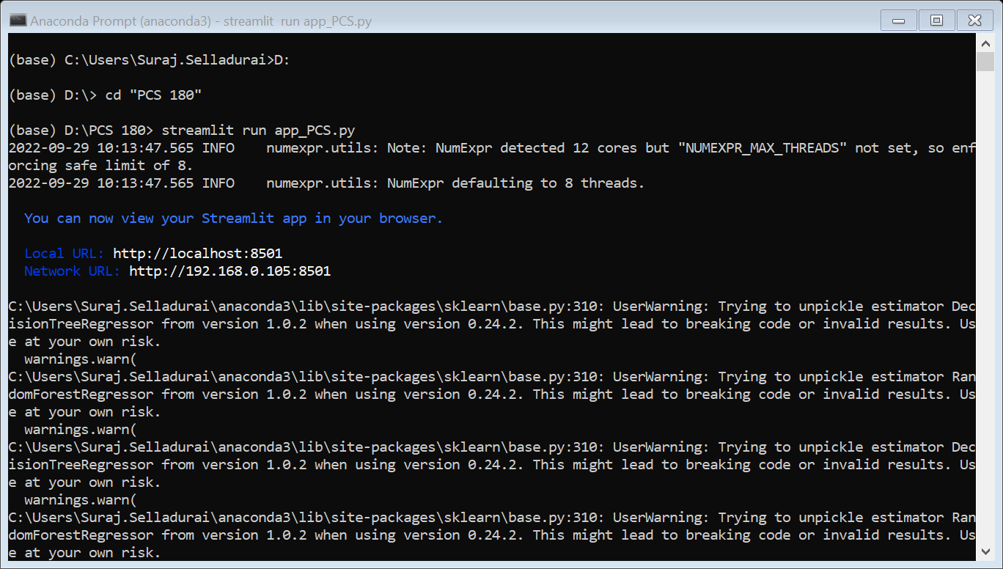

1. Once the right directory is opened, use the command < streamlit run app_PCS.py > and the application will open in your web browser.
2. To get the basic idea of the dataset, pandas profiling is carried out which shows the size of the dataset and correlations etc and after uploading the raw dataset the pandas profile report is generated.

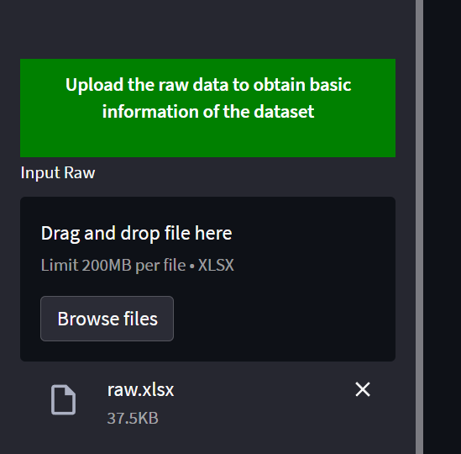

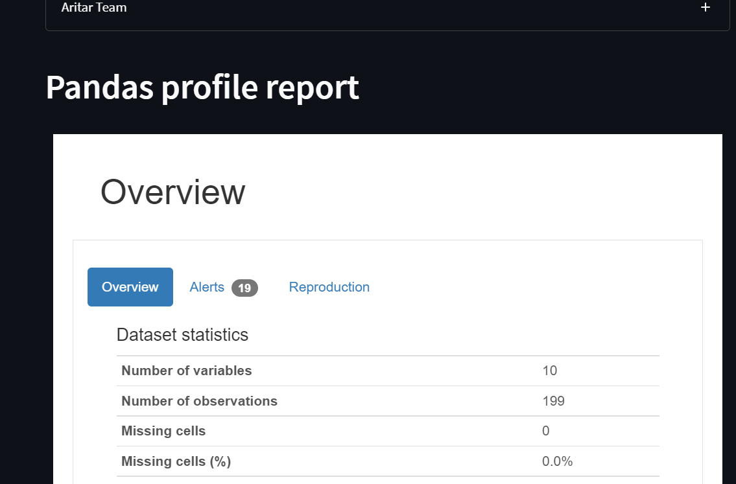

1. In the web browser the app can either run through:
2. Uploading an existing file from the sidebar and then clicking “Press to predict Max Coil DP using Input Data” and you can get the predicted values

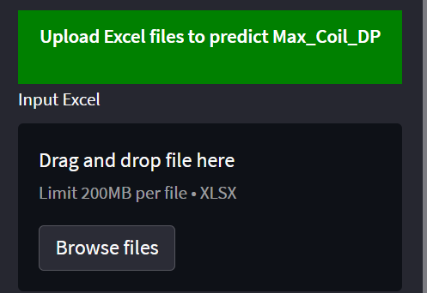

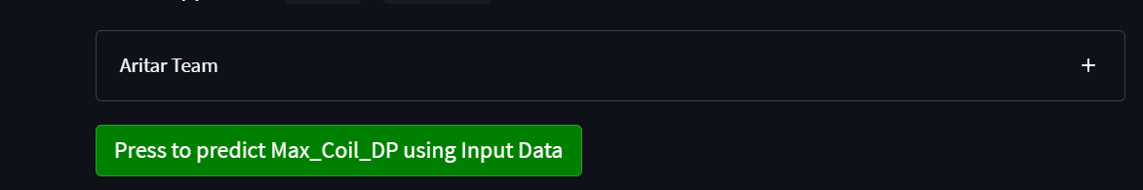

1. You can manually enter the values using the slider and get the predicted value.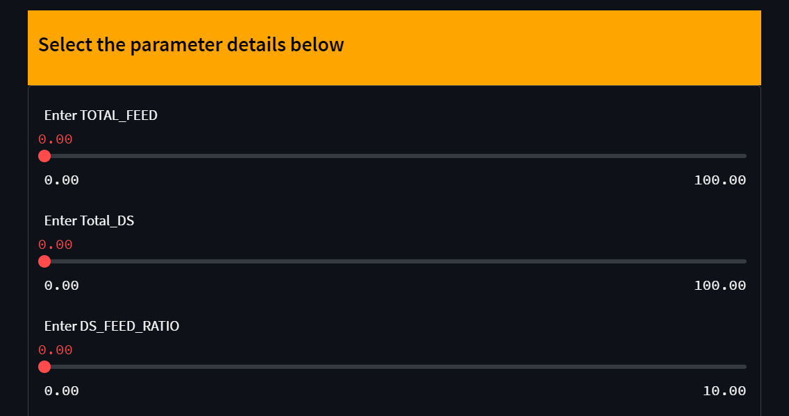

**NOTE: It may take a couple of minutes while executing to get the result**